Assignment

Topic: Network Fundamentals and Building Networks

1. Wireshark Capture
After installing Wireshark, I started capturing packets on my WiFi network interface and visited instagram.com. After stopping the capture, I observed the following protocols:
No. | Protocol
1 | DNS
2 | TCP
3 | TLSv1.3
4 | HTTP/2 (or HTTP)
5 | QUIC
6 | UDP
7 | ARP
8 | ICMP
Observation: The browser first performs a DNS lookup, then establishes a TCP or QUIC connection, creates a secure TLS connection, and finally exchanges web data.

2. Three Packets and Their OSI Layers
Packet | OSI Layer | Explanation
HTTP | Application (Layer 7) | Transfers webpages and user data.
TCP | Transport (Layer 4) | Ensures reliable delivery of packets.
IP | Network (Layer 3) | Routes packets across networks.

3. OSI Model Diagram
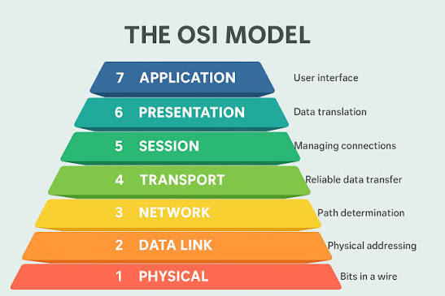
Layer 7 - Application: WhatsApp, Instagram
Layer 6 - Presentation: Images, Encryption
Layer 5 - Session: Login Session
Layer 4 - Transport: TCP, UDP
Layer 3 - Network: IP Address
Layer 2 - Data Link: WiFi, Ethernet
Layer 1 - Physical: WiFi Signals, Cables

4. WhatsApp Message Through OSI Model
When I send a WhatsApp message, the Application layer prepares the message. The Presentation layer encrypts it. The Transport layer breaks it into packets and ensures delivery. The Network layer routes the packets using IP addresses. The Data Link layer sends them over WiFi or mobile networks, and the Physical layer transmits them as radio or electrical signals. The receiver processes the layers in reverse order to display the message.

